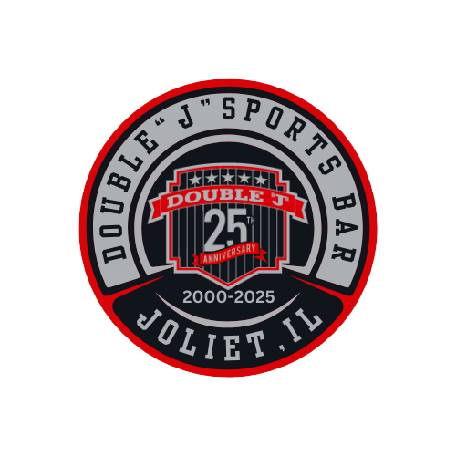
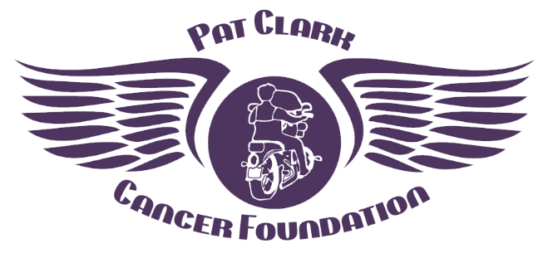

Double “J” Sports Bar 2026 Golf Classic
Saturday, August 1, 2026
Sponsorship Opportunities
Double “J” Sports Bar is partnering with the
Pat Clark Cancer Foundation to raise funds for local cancer patients.
Please consider becoming a sponsor and help us help others.

All sponsorships include name on signage at event and all social media.

○ Hole Sponsor (1) - $100 (2) - $150 (multiple available)
○ Game Sponsor - Putting or Longest Drive or Closest to the Pin - $150 (three available)

○ Bloody Mary Bar Sponsor - $1, 000 (one available)
○ Golf Ball Sponsor - $750 (one available)
○ Cart Sponsor - $250 (one available)
○ Driving Range Sponsor - $250 (one available)
○ Raffle Sponsor - $250 (one available)
○ Dinner Sponsor – $750 (one available)
○ Lunch Sponsor - $750 (one available)
○ Hole in One for $10,000 Sponsor - $750 (one available)
○ Raffle Prize Donor – multiple needed

Name/Company ________________________________________________________
Address________________________________________________________________
City/State/Zip___________________________________________________________
Phone # and email _______________________________________________________

Please make checks payable to the Pat Clark Cancer Foundation
1552 Bryan Court, Aurora, IL 60504. Or pay online at patclarkcf.org
All payments, along with jpg of logo or words for the sign, must be received by July 18, 2026
The Pat Clark Cancer Foundation is a 501(c)(3) organization.
All donations are tax deductible as allowed by law.
Questions? Please contact Susan 815.260.2257 or patclarkcf@gmail.com

